Calwa Recreation & Park District

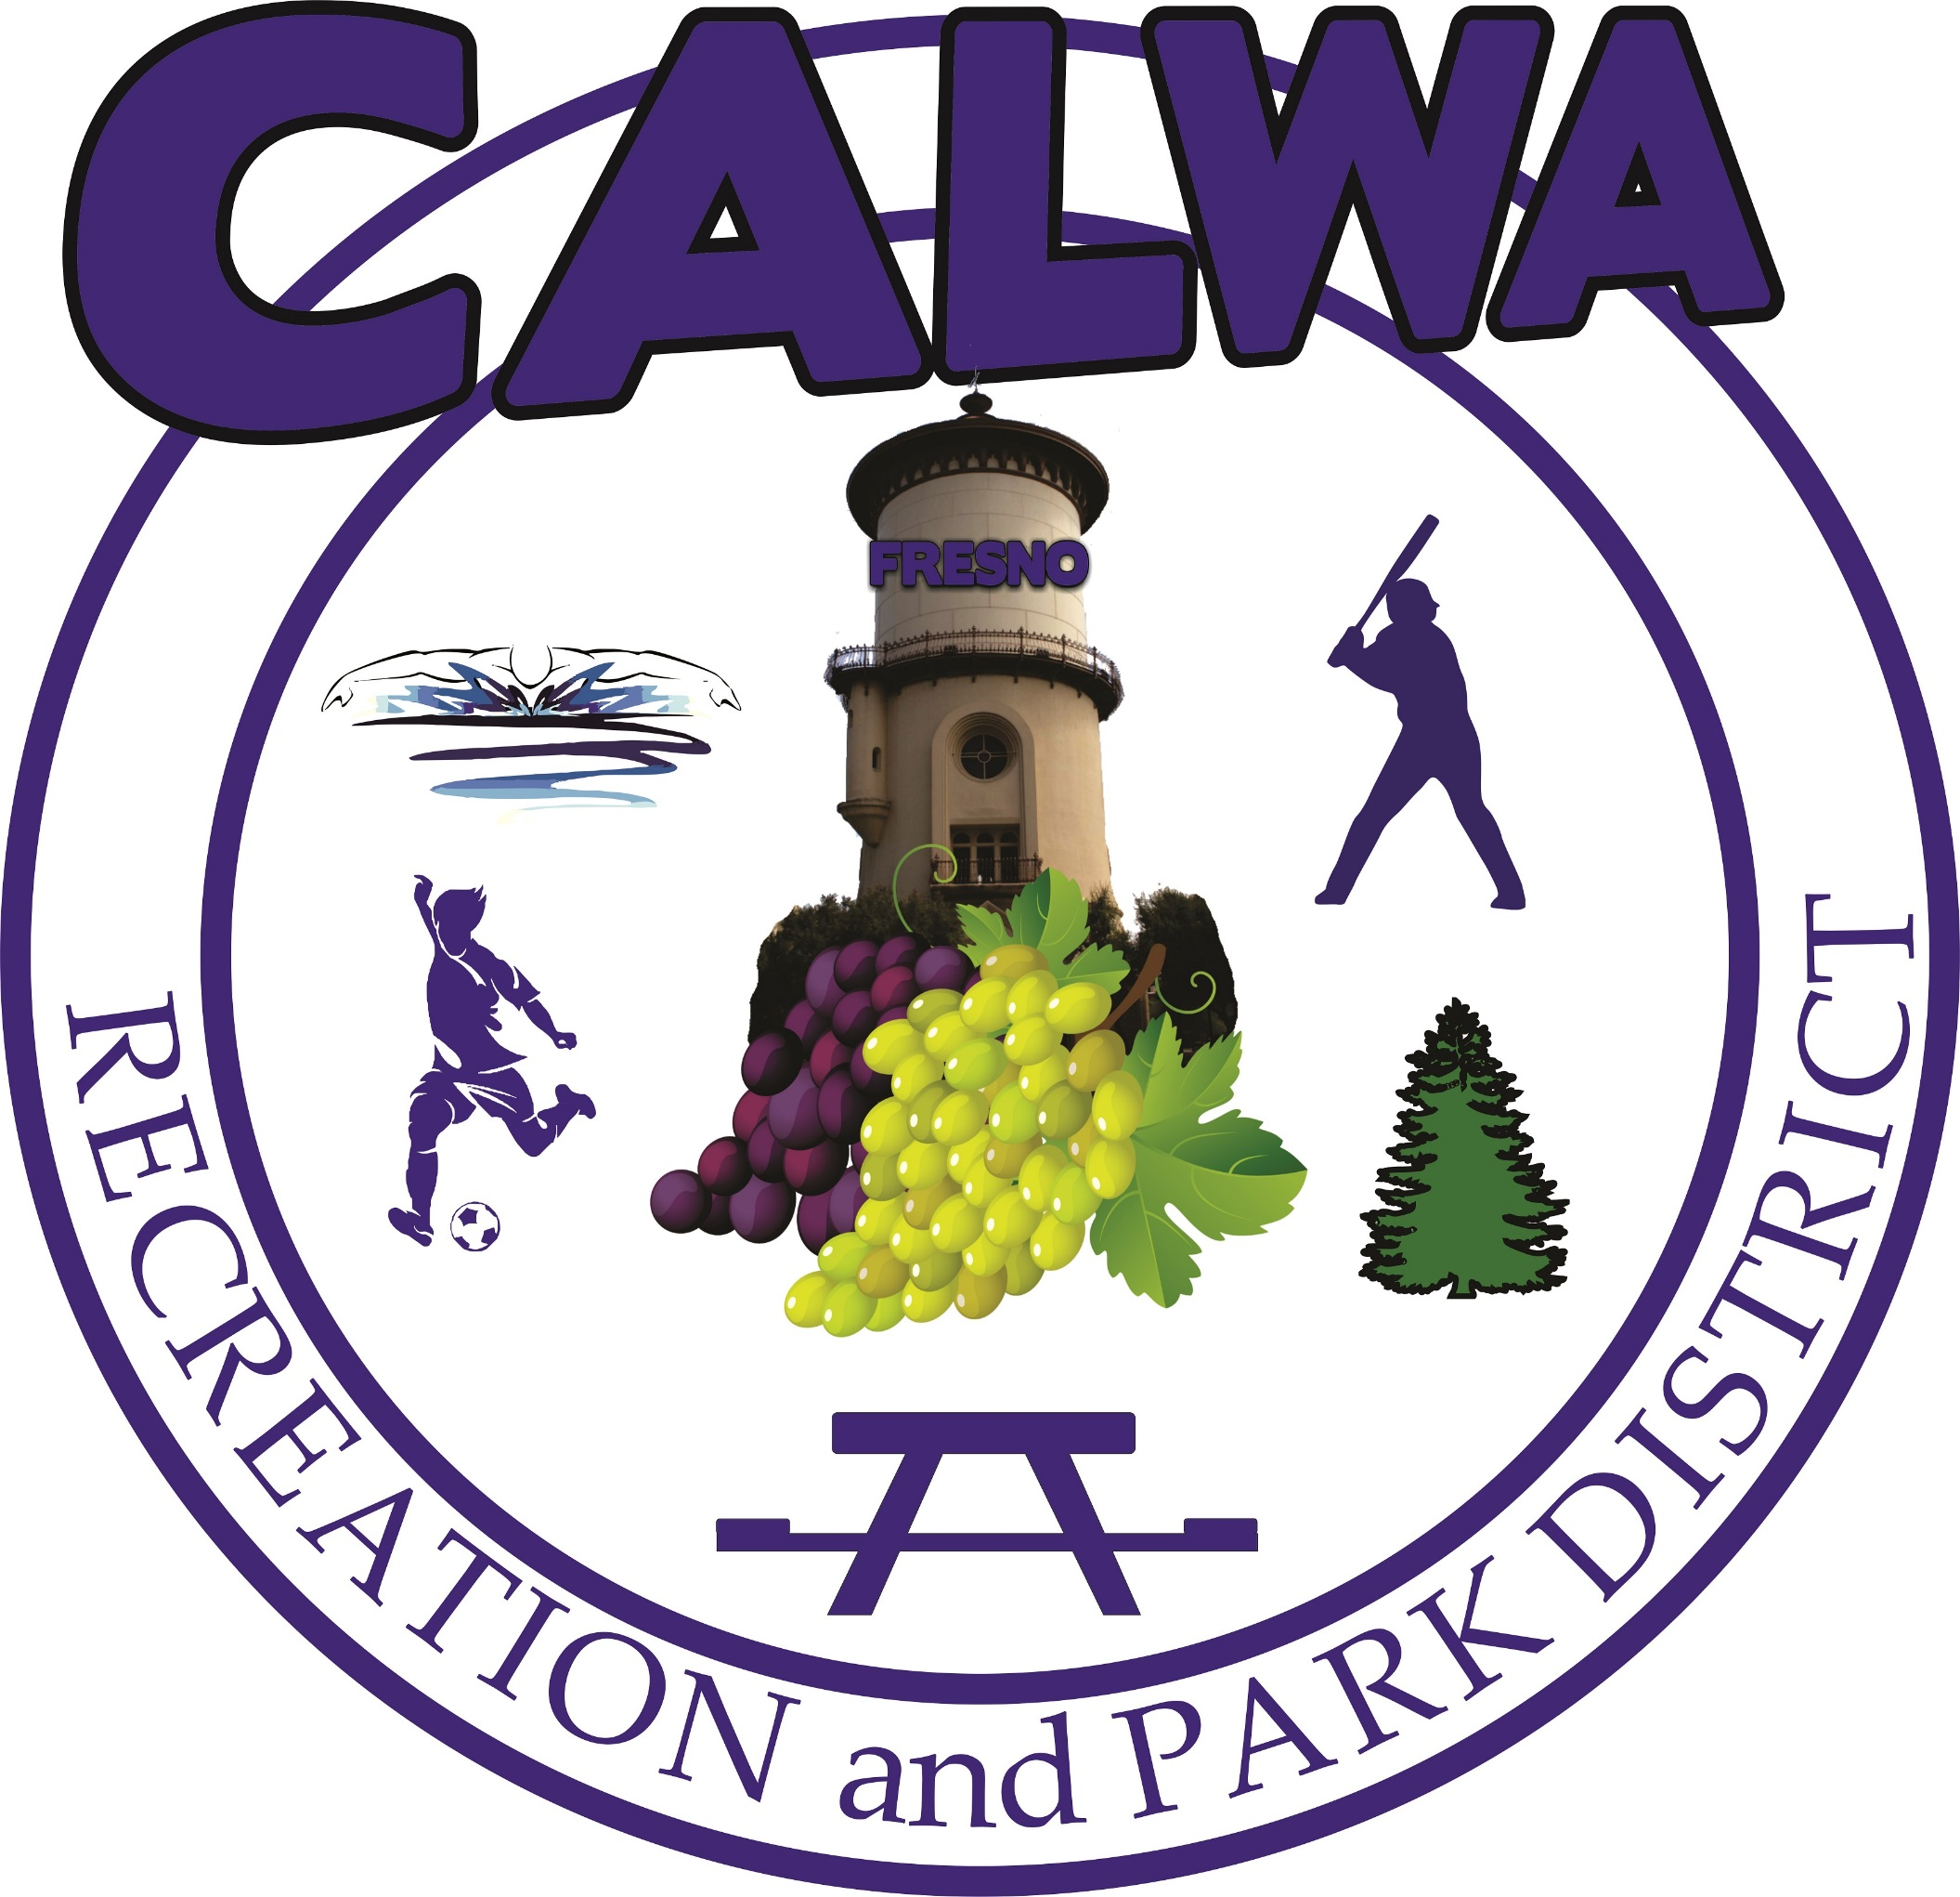
4545 E. Church Avenue, Fresno, CA 93725 • Phone: (559) 264-6867

Mary L. Rosales Raúl Guerra José Luis Sánchez Gabriela Mares Esmeralda Zamora
Board Member Board Member Board Member Board Member Board Member
Chair Vice-Chair

Vacant Hilda Cantú Montoy
District Administrator www.calwarecreation.org District Counsel

NOTICE AND CALL OF SPECIAL BOARD MEETING

Location: 4545 E. Church Avenue, Fresno, CA 93725
Date: Monday, July 10, 2017
Time: 5:30 PM

The Calwa Recreation and Park District Board of Directors welcomes you to its meetings and encourages you to participate. This Special Board meeting has been called by the Board Chair. All attendees are advised that pagers, cell phones, and any other communication devices should be powered off upon entering the Board meeting.

Members of the public shall have an opportunity to speak on the agenda items and will be limited to three minutes per item. The sole business to be conducted at this meeting is as follows:

1. Call to Order.

2. Roll Call.

3. Invocation and Flag Salute.

4. Approval of Agenda.

5. Matters Needing Attention Due to Lack of Administrative Staff – Discuss, give direction, and take action on the following matters:

A. Recruitment of District Administrator Tasks Needed:
(1) Posting of the Job Opening, new Job Description, and the Application on Website
(2) Have folder with Application and Job Descriptions available in case anyone asks.
(3) Post at other potential sites such as Special Districts Association
(4) Place Fresno Bee Ad
(5) Take down old job description from the website.

B. Recruitment of Program & Operations Manager

- Proceed with working with Temp Agency to get someone hired. Report from Director Mares per Board direction of last meeting.
- Consider offer from former Program & Operations Manager to assist a few hours per week.
(3) Recruitment of Permanent Position
(a) Posting of the Job Opening, new Job Description, and the Application on Website
(b) Have folder with Application and Job Descriptions available in case anyone asks.
(c) Post at other potential sites such as Special Districts Association

C. EDD Claim – Discussion regarding EDD claim filed by former employee and response filed by Chair.

D. AC UNIT – The work requires prevailing wages. All American Agreement does not perform prevailing wages work. The next bidder should be considered per the emergency resolution.

E. AC Temporary Units – Status of Action taken by Board to purchase and further action if necessary.

F. Events Scheduled at Hall – Discussion on status; direction to be given.

G. Status of County Forms and Bank forms and whether anything else is needed.

H. Budget Hearing:
- Discussion and direction on publication required for August 15, 2017 Public Hearing.
- Update from Director Guerra on preparation of the Final Budget.

- Status of Action taken by Board regarding purchase of:
- Signs;
- Cameras.

6. Adjournment.

This notice is given pursuant to CA Government Code Section 54956 and this notice shall also be posted at least 24 hours prior to the special meeting in a location that is freely accessible to members of the public at the District and on the District’s website www.calwarecreation.org.

Agenda packets and other public documents are available for inspection by the public at the District Office located at 4545 E. Church Avenue, Fresno, CA. To receive meeting agendas by email, you can be added to the mailing list by calling (559) 264-6867 or sending your request by email to info@calwarecreation.org.

Next Regular Meeting
Tuesday, July 18, 2017
6:30pm

